Deep learning models of IPF Diagnosis with Optimizing the Slice Sampling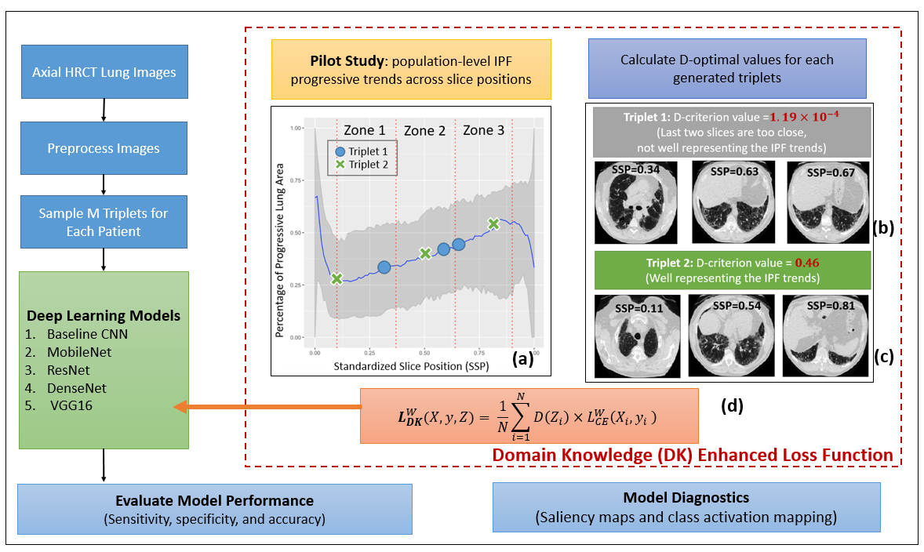
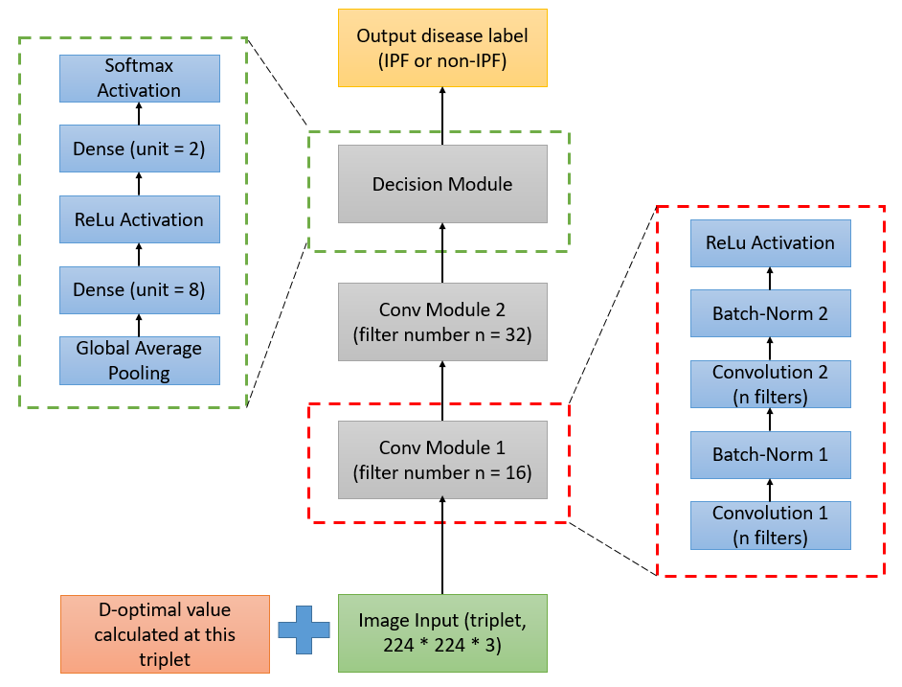

Figure 1. Summary of automatic diagnosis for IPF. Top (flow chart): SSP: standardized slice position, DK: domain knowledge with optimization, CE: cross entropy without optimization in selecting slices; Bottom: Baseline CNN architecture

We first defined a standardized slice position (SSP) to align subject visits with a varying number of HRCT slices. We define $SSP= \frac{x-1}{N_{s}-1},$ where $x$ the current slice number is and $N_{s}$is the number of slices for that subject visit, and y is IPF or not (=1 or 0, respectively). SSP ranges from 0 to 1, where 0 is the first HRCT slice at the very top of the lung and 1 is the last HRCT slice at the very bottom of the lung.

